NEW JERSEY STATE BAR FOUNDAITON
COURTROOM ARTIST CONTEST

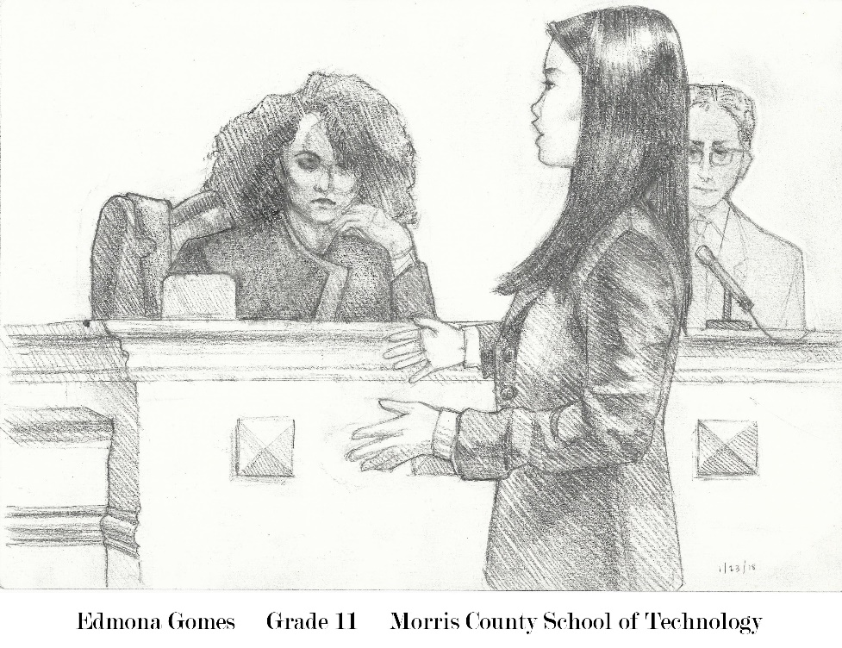
First Place 2018

IMPORTANT DATES
FOR 2018 – 2019 COURTROOM ARTIST CONTEST
2018
OCTOBER 17: ART EDUCATORS WORKSHOP
2019
JANUARY 4: SKETCH REGISTRATION FORMS DUE
FEBRUARY 20: SKETCH IMAGES DUE
MARCH 26: PRESENTATION OF AWARDS/MOCK TRIAL FINALS

For Questions or More Information Email to: cpellegrino@njsbf.org

